# Report on Electrical Fault detection and Classification

# Description about the problem

# This Project we are focuses on the detection and classification of the faults on electrical power transmission line using different classifiers. The three phase currents and voltages of one end are taken as inputs in the proposed scheme.

# The simulation results concluded that the present method based on the Decision Tree Classifier is efficient in detecting and classifying the faults on transmission lines with satisfactory performances. The different faults are simulated with different parameters to check the versatility of the method.

# Steps:

First of all, we importing all necessary libraries and reading the csv files. After that come the most crucial part which is EDA (Exploratory data analysis) and do some visualization to know the data. Means what are the insights or patterns of the data. After performing this we find the relation between the data to see how much independent variable or correlated to each other. It also called feature engineering. We checking for missing values but no found in data and we apply many classifiers on our data to check that which give better performance and we found the decision tree classifier is best from all of other so we choose it for our final prediction. At last we also see our result through visualization and we compare our results through graph.

# Comparison between the model

Now we check the performance of each models on training and testing data.

# 

From above fig we can see that Decision Tree giving good performance on training data as compare to other classifiers. It give good accuracy on detection and also good in class Accuracy.

# Detection Accuracy Graph

# 

# Class Accuracy Graph

# 

You also see from above figure through the graph of detection accuracy and through class accuracy as I discuss previously that Decision tree giving the good as compare to others.

**SVM confusion matrix**

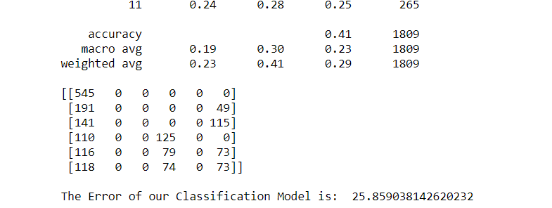

**Logistic Regression**

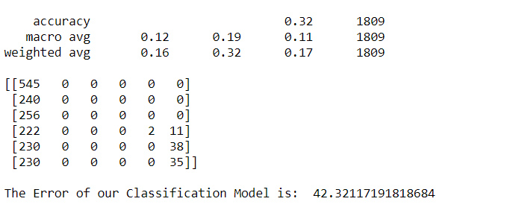

**Decision Tree Classifier**

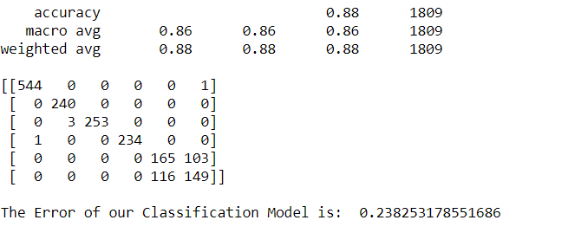

Now though confusion matrix you can also see that decision tree give better performance as compare to others so we choose our decision tree classifier for this.